Oysters: Bringing us together

NSW Oyster Conference – Merimbula

22-24th August 2017
www.nswoysters.com.au/2017conference

Thank you for your interest in supporting the 2017 NSW Oyster Conference – Oysters: Bringing Us Together. To help us prepare for your participation in the event, please fill in your details below, and indicate your level of sponsorship.

Organisation / Company:
Address:
Contact name:
Contact phone
Contact email:
Please provide a copy of your logo. Attached? |  | Yes / No
Sponsorship level:  - Dinner sponsor | $10,000 | Yes / No
- BBQ sponsor | $5,000 | Yes / No
- Gold sponsor | $4,000 | Yes / No
- Silver sponsor | $2,000 | Yes / No
- Bronze sponsor | $1,000 | Yes / No
- Trade display | $300 | Yes / No
TOTAL | $ | All prices are GST inclusive

Please provide details of any product you would like to donate for the dinner auction

The NSW Farmers Association are administering the accounts for this event, and will invoice you shortly. Please return this form, and a copy of your company / organisation logo, to:

Andy Myers
Andy@oceanwatch.org.au
T: (02) 9660 2262
M: 0488 656 366
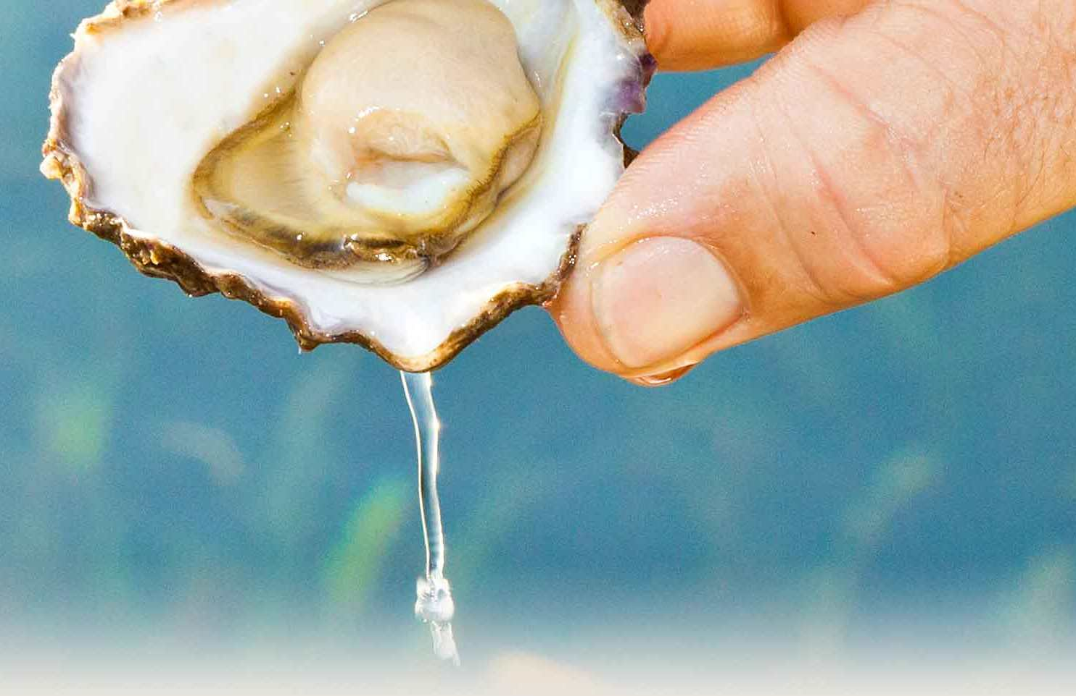  Sponsorship & Trade Display Opportunities:  Dinner Sponsor = $10,000  Dinner naming rights. Acknowledgment & logo in conference notices & program. Banner displayed at Conference Dinner. Opportunity to address conference dinner. Acknowledgment by conference dinner MC. Two full conference tickets incl. dinner tickets.  BBQ Sponsor = $5,000  A social night on the opening night with oyster farmers & trade displays under one roof. Acknowledgment and logo in conference notices & program. Banner displayed at BBQ. Opportunity to address evening attendees. Acknowledgement by conference convener in opening & closing remarks. Two full conference tickets incl. dinner tickets.  Gold Sponsors = $4,000  Prominent acknowledgement as Gold sponsor & large logo in conference notices & program. Priority location for two banner displays at all conference sessions. Opportunity to address conference. Acknowledgement by conference convener in opening & closing remarks. Two full conference tickets incl. dinner tickets.  Silver Sponsors = $2,000  Acknowledgement as Silver sponsor & logo in conference notices and program. Banner display at all conference sessions. Acknowledgement by conference convener in opening & closing remarks. Two full conference tickets incl. dinner tickets.  Bronze Sponsors = $1,000  Acknowledgement as Bronze sponsor & small logo in conference notices & program. Banner displayed at all conference sessions. Acknowledgement by conference convener in opening & closing remarks. Two full conference tickets incl. dinner tickets.  Trade Display = $300  Tea/coffee & lunch throughout event, and dinner ticket for one.  Auction Sponsors = Provision of items to auction  Display of item at conference dinner. Announcement of item at auction, description of item & acknowledgement of donor by auctioneer.  All prices are GST inclusive |  | Come and hear the latest news in the NSW oyster industry  Workshops, talks, field trips & conference dinner  Dedicated trade & networking evening  Meet up with oyster farmers from other regions of NSW & interstate  Don’t miss out!  Merimbula, NSW  22-24 August 2017

